End users –

Primary – Foreign Language Learner. Foreign Language Teacher

Secondary – Gamer. Parent

New user vs saved user –

“As a new user, I want to be introduced to the game, so that I can become familiar with the layout, user interactions, and teaching philosophy.” EPIC

“As a new user, I want to enter my personal profile details, so that my progress can be saved and retrieved for future playthroughs of the game.”

“As a new user, I want to watch a video which shows how gameplay works, so that I can become familiar with how to play the game.”

“As a new user, I want to watch a video which explains the teaching philosophy/level progression and construction, so that I am aware of why I am learning with this method.”

“As a new user, I want to watch a video about navigating the UI and menus, so I can become familiar with how to navigate the game.”

“As a new user, I want the option to skip the intro/tutorial section, so that I can quickly dive into learning and playing the game.”

“As a saved user, I want to pick up where I left off, so that I don’t waste time repeating unnecessary steps.”

Camera follow -> Wider room -> more sandwich choices -> more toppings

“As a gamer, I want the camera to follow my character, so I can have access to a wider room while maintaining high visibility of graphics.”

“As a foreign language learner, I want more base food options, so I can learn more base food words in my target foreign language.”

“As a foreign language learner, I want more toppings options, so that I can learn more toppings in my target foreign language.”

“As a gamer, I want a wider room, so that I can have a scene big enough to accommodate the items/words/concepts I am trying to learn.”

Cash register subscene (customers take food, go away to eat for a while (possibly zoom out camera to show tables/seating area where customers will eat), then return to pay at a cash register, which will include the player needing to handle giving correct change by reading a receipt and tapping on bill and coin sprites in a register)

“As a foreign language learner, I would like to practice interacting at a cash register, so that I can learn the foreign money of my target country.” EPIC

Bring the bill

“As a foreign language learner, I would like to manage bringing the bill, so I can learn how to ask for the bill in my target foreign language.”

Multiple customers

“As a gamer, I would like multiple customers, to increase the excitement and challenge of the game.”

“As a foreign language learner, I would like multiple customers, to make sure my learning reaches a practical standard.”

“As a gamer and foreign language learner, I would like to tap on a customer to ask for their order, so that I can manage taking orders from multiple customers.”

“As a gamer, I want the customers to have impatience meters, so that I can increase the excitement and challenge of the game.”

“As a foreign language learner, I want my overall score to be affected by customer patience meters, so that I can gauge my repertoire at a practical standard.”

Customers walking to target spots on counter

“As a gamer and foreign language learner, I would like customers to walk to designated spots, so that dialogue boxes are managed and the challenge isn’t too difficult.”

Animated customers

“As a gamer and foreign language learner, I would like the characters to be animated, to help create an immersive experience.”

Animated chef

“As a gamer and foreign language learner, I would like the characters to be animated, to help create an immersive experience.”

Background music/Ambience sfx

“As a gamer and foreign language learner, I would like there to be background music and ambience sfx, to help create an immersive experience.”

Progressive level system (ideally, a first time user should start with only the hamburger and lettuce, with the potential orders only being a plain hamburger or a hamburger with lettuce… then after a certain accuracy standard is achieved, the next topping is added, etc. etc.)… popups explain new words/items and their grammatical usage as levels progress

“As a foreign language learner, I would like a progressive level system, so that I can effortlessly master target words and phrases.”

Other levels (pizzeria, fruit/veg stand, café, bar, etc.)

“As a foreign language learner, I would like other levels/scenes, so that I can learn words and phrases in my target language in multiple settings.”

Switch burger building graphic solution to ‘open’ bun style where it can be more visually clear which items have been placed on the burger.

“As a gamer, I would like the hamburger to be an open bun graphic, so that I can more easily see the toppings I’ve gathered.”

Put back incorrect items from burger being built or trash can feature.

“As a gamer, I would like a trash can feature, so that I can deliberately acknowledge that I’ve made a mistake with an order.”

Gamifications – timed rounds, leader boards/saved scores, earn badges/rewards

“As a gamer, I would like additional gamifications, to increase the excitement and challenge of the game.”

Study/review screen – a UI screen that provides pictures of, text, and audio of learned concepts/words (example: a picture of a tomato has the text word tomato in the target language above it and an audio button which plays an audio clip of the item in the target language)

Debug mode cheats/jumping

“As a developer, I would like a debug mode, so that I can quickly jump to areas/game states that need debugging.”

Video tutorials

“As a foreign language learner, I would like video tutorials, so that I can easily become familiar with the gameplay, UI layout, and teaching philosophy.”

Refactor code/objects

“As a developer, I would like to work with abstracted code, prefabs, and other similar concepts, so that I can quickly navigate code and use replicable/already invented objects/solutions.”

Play as the customer

“As a teacher, I want my students to order correctly, so they can practice grammar.”

MAKE WIREFRAMES FROM SCREENSHOTS OF PROTOTYPES

MAKE STORYBOARDS FOR FEATURES

**Step 4.1** Click on your card. On the right hand side menu, under "POWER-UPS", click on **Get Power-Ups:**

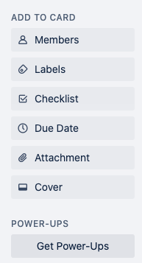

**Step 4.2** In "Featured", look for "Custom Fields". Alternatively, you can also search for it. Click on the great button "**Add**".

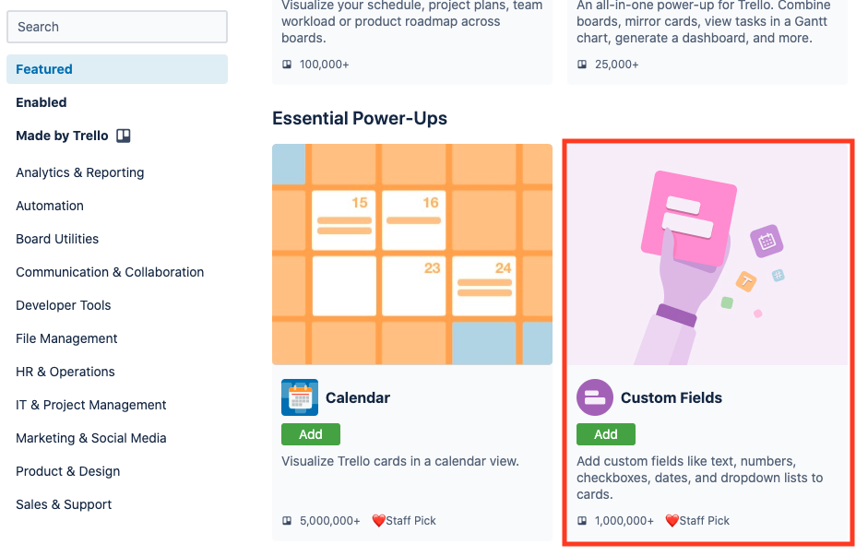

Now go back to our board, you can see that "Custom Fields" is added under **POWER-UPS**:

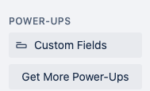

**Step 4.3** Click on Custom Fields, and select "New Field". Choose "Dropdown" as its type:

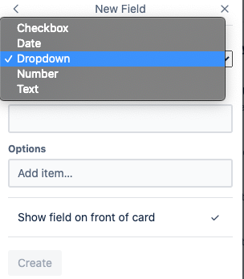

Let's put "Priority" as its name, and start filling in items as options:

**Must-Have; Should-Have; Could-Have; Won't-Have.** (Note: press key "Enter" after entering every item)

**Step 4.4** You can also assign some colors to each option. Note that there's no particular color associated with any priority; alternatively, you can also use color for Risk, or even Estimate.

In this tutorial, we are adding colors for better illustration. Let's use red for must-have, yellow for should-have, and green for could-have. Leave "won't-have" with the default grey.

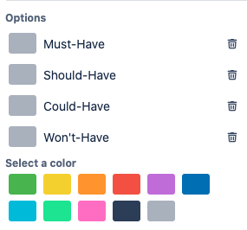

In the end, it should look like this:

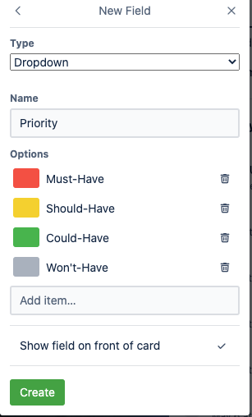

Click "**Create**"

**Step 4.5** In your card, you should be able to see Custom Fields. Since the first User Story is a "Must-Have" Story, let's assign a priority for it:

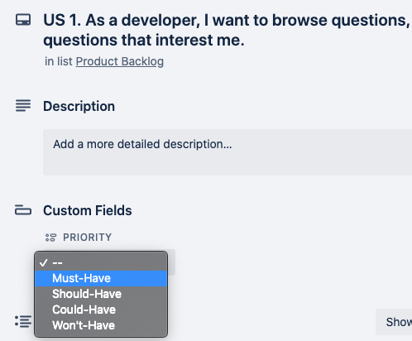

And in your **Product Backlog** list, your card should update automatically:

